Chapter 3: Principles of Pipelining and Vector Processing
3.1–3.6 Pipelining, Hazards & Linear/Non-linear Pipelines
- Pipelining doesn’t decrease the time required for the execution of a single instruction; then how can it increase the overall throughput? Explain. (2025 Fall)

Pipelining doesn’t decrease the time required for a single instruction; then how can it increase the overall throughput?
Pipelining increases throughput through overlapped execution of multiple instructions. It does not reduce the instruction latency of an individual instruction.

1. Instruction Latency
- Instruction latency is the total time required to execute one instruction.
- Pipelining does not decrease this time and may slightly increase it due to pipeline overhead.

2. Overlapped Execution
- An instruction is divided into several stages such as Fetch, Decode, Execute, and Write-Back.
- Different instructions can execute in different stages simultaneously.
- For example, while Instruction 1 is being executed, Instruction 2 can be decoded and Instruction 3 can be fetched.

3. Increased Throughput
- After the pipeline is filled, one instruction can be completed in every clock cycle.
- Thus, pipelining increases the number of instructions completed per unit time.

Example
For a 4-stage pipeline:
- Non-pipelined: 4 cycles per instruction.
- Pipelined: After the pipeline is filled, approximately 1 instruction per cycle.
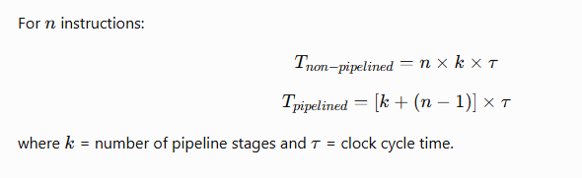

Conclusion
Pipelining does not make an individual instruction faster; instead, it allows multiple instructions to execute simultaneously in different stages, thereby increasing instruction throughput and improving overall system performance.

- What are the linear and non-linear pipelines? Explain (2025 Fall)

Linear and Non-Linear Pipelines
Pipelining is a technique of dividing a computation into several stages so that different operations can be performed concurrently.

1. Linear Pipeline
A linear pipeline consists of processing stages connected sequentially. Data enters through the first stage and moves through each stage in a fixed order until it reaches the final stage.
Features:
- Has k sequential stages:
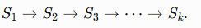
- Data follows a fixed path.
- No feedback or bypass connections.
- Usually performs a single fixed function.
- Produces output from the last stage.
- Control and scheduling are relatively simple.
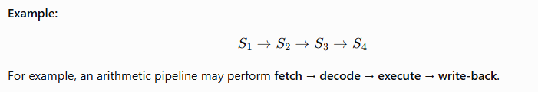

2. Non-Linear Pipeline
A non-linear pipeline has a more complex structure with feedforward and feedback connections between stages. Therefore, data may follow different paths depending on the operation.
Features:
- Contains feedback and/or feedforward paths.
- Data may bypass or revisit certain stages.
- Can perform different functions.
- Output may come from an intermediate or final stage.
- May require multiple reservation tables.
- Scheduling is more complex because stage conflicts/collisions may occur.
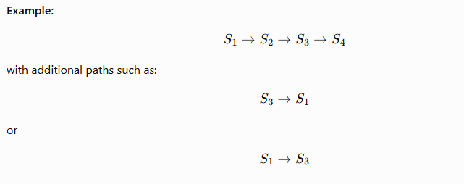

Difference Between Linear and Non-Linear Pipeline
Basis | Linear Pipeline | Non-Linear Pipeline
Structure | Sequential | Complex
Data path | Fixed | Multiple paths
Connections | Mainly forward | Feedforward and feedback
Function | Fixed function | Multiple functions
Output | Last stage | Intermediate/final stage
Reservation table | Usually one | Multiple
Scheduling | Simple | Complex
Stage conflicts | Less likely | More likely
Flexibility | Low | High
In short: A linear pipeline follows one fixed sequence of stages, whereas a non-linear pipeline allows multiple paths through the stages using feedforward and feedback connections.

- Processor pipelining (Short Note, 2025 Fall)
- Explain the concept of pipelining in computer architecture. How does pipelining improve the performance of a processor? Derive relation of speedup due to pipeline and discuss. (2024 Fall)

Concept of Pipelining in Computer Architecture
Pipelining is a technique in which multiple instructions are processed simultaneously by dividing CPU hardware into several sub-operation stages such as Instruction Fetch, Decode, Operand Fetch, Execute, and Write-Back using interface registers/latches between stages.

How Pipelining Improves Performance
- Overlapped Execution: Different stages work on different instructions simultaneously.
- Higher Instruction Throughput: After the pipeline is filled, ideally one instruction completes every clock cycle.
- Minimizes Processor Idle Time: While one instruction moves to the next stage, another instruction enters the pipeline.
- Higher Clock Rate: Dividing execution into smaller stages reduces the propagation delay of each stage.

Speedup Relation
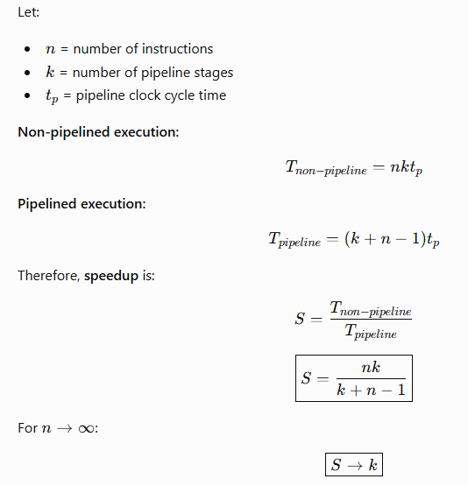
Thus, the maximum theoretical speedup of a (k)-stage pipeline is (k).

Limitations
Actual speedup is reduced by pipeline register overhead, stage imbalance, and pipeline hazards such as structural, data (RAW, WAR, WAW), and control hazards.
Conclusion: Pipelining does not reduce individual instruction latency; it increases instruction throughput through overlapped execution.

- Pipeline hazards (Short Note, 2024 Fall & CA / Old)
- What is pipelining? How can it increase the efficiency of the computer system? Explain the instruction pipelining with a typical example. (2025 Fall Mock & 2025 Fall New)
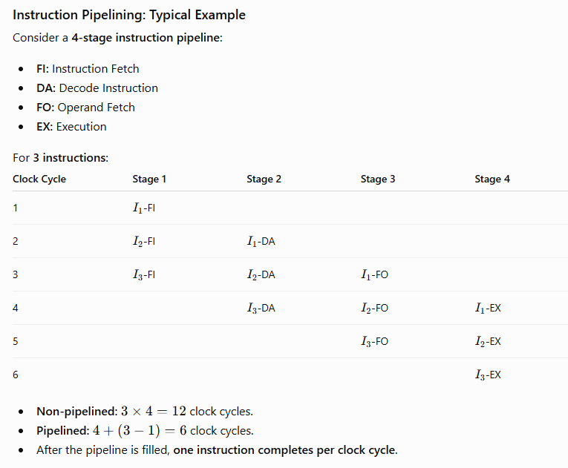

Conclusion
Pipelining improves computer efficiency through overlapped instruction execution, increasing instruction throughput and reducing hardware idle time, although it does not reduce the latency of an individual instruction.

- What is arithmetic pipelining? With suitable examples and derivations describe how it speed up the computation? (CA / Old)

Arithmetic Pipelining
Arithmetic pipelining is a technique in which a complex arithmetic operation is divided into several sequential stages. Each stage performs a specific sub-operation, and interface registers/latches store intermediate results between stages. This allows multiple data items to be processed concurrently, increasing throughput.

Example: Floating-Point Addition
A floating-point addition pipeline can have four stages:
- Exponent comparison: Find the difference between exponents.
- Mantissa alignment: Shift the mantissa of the smaller exponent.
- Mantissa addition: Add the aligned mantissas.
- Normalization: Normalize the result and adjust the exponent.
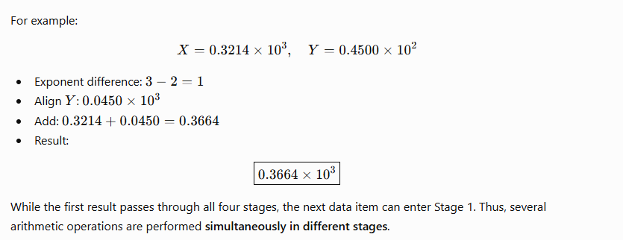

How Arithmetic Pipelining Speeds Up Computation
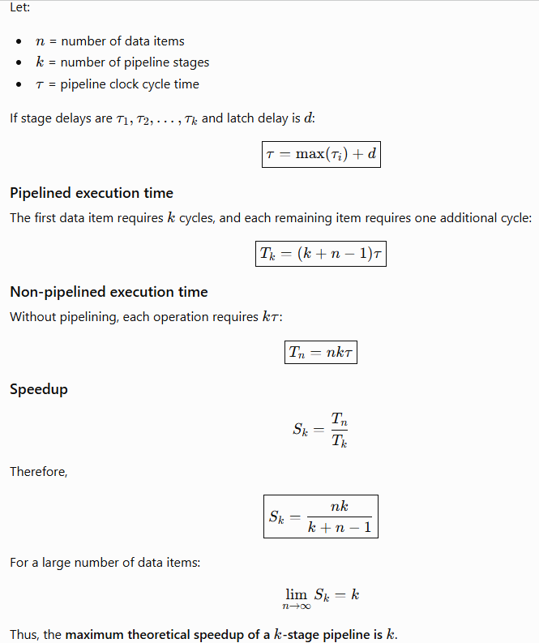
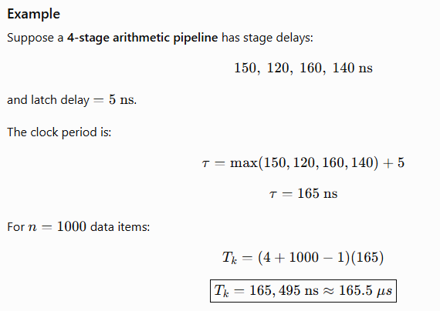

Conclusion
Arithmetic pipelining improves performance through overlapped execution, better hardware utilization, and increased throughput. It does not significantly reduce the latency of one arithmetic operation; instead, after the pipeline is filled, one result can be produced every clock cycle.

- Identify the RAW, WAR, and WAW dependencies in the following instruction sequence and suggest appropriate solutions to overcome: I1: R1 = 100, I2: R1 = R2 + R4, I3: R2 = r4 - 25, I4: R4 = R1 + R3, I5: R1 = R1 + 30. (2025 Fall New)
3.7 Dynamic Instruction Scheduling
- Tomasulo's Algorithm (Short Note, 2025 Fall)
- Dynamic Instruction Scheduling (Short Note, 2025 Fall Mock)

Dynamic Instruction Scheduling
Dynamic instruction scheduling is a hardware-based pipeline technique in which the processor dynamically detects instruction dependencies and decides the execution order at run time. Instructions may execute out of order when their operands and functional units are available, while the final result is normally committed in program order.

Why is it needed?
In a traditional in-order pipeline, one stalled instruction can block later independent instructions.
Example:
DIV.D F0, F2, F4
ADD.D F10, F0, F8
SUB.D F12, F8, F14
- DIV.D has a long execution time.
- ADD.D depends on the result of DIV.D, so it must wait.
- SUB.D is independent and can execute immediately.
- Dynamic scheduling allows SUB.D to bypass the stalled ADD.D and execute out of order.
Thus, processor resources remain busy and instruction throughput increases.

Main Features
- In-order issue: Instructions are fetched/issued in program order.
- Out-of-order execution: Ready instructions execute without waiting for earlier stalled instructions.
- Out-of-order completion: Instructions may finish at different times.
- In-order commit: Results are finally committed in program order to maintain correct program state.

Main Techniques
1. Scoreboarding
- Uses a centralized control unit called a scoreboard.
- Tracks functional units, registers, and instruction dependencies.
- Allows safe out-of-order execution.
- Does not use register renaming, so WAR and WAW hazards must be handled.
2. Tomasulo's Algorithm
- Uses reservation stations to hold waiting instructions.
- Uses register renaming to eliminate WAR and WAW hazards.
- Uses a Common Data Bus (CDB) to broadcast completed results.
- Allows efficient out-of-order execution.

Conclusion
Dynamic instruction scheduling improves processor performance by allowing independent instructions to execute while dependent instructions are waiting. Scoreboarding and Tomasulo's algorithm are important scheduling techniques, while the ROB helps maintain correct program state and precise exceptions.

- Instruction Parallelism (Short Note, CA / Old)
3.8–3.11 Vector Processing & Vectorization
- What is vector processing? What are the different types of vector instructions? Explain. (2025 Fall)

Vector Processing
Vector processing is a computer architecture technique in which a single instruction operates on multiple data elements of a vector (array) simultaneously. A vector processor uses vector registers and pipelined functional units to perform parallel operations efficiently.
Compared with scalar processing, vector processing reduces loop overhead, improves instruction-level parallelism, and increases throughput. Converting scalar code into vector operations is called vectorization.

Types of Vector Instructions
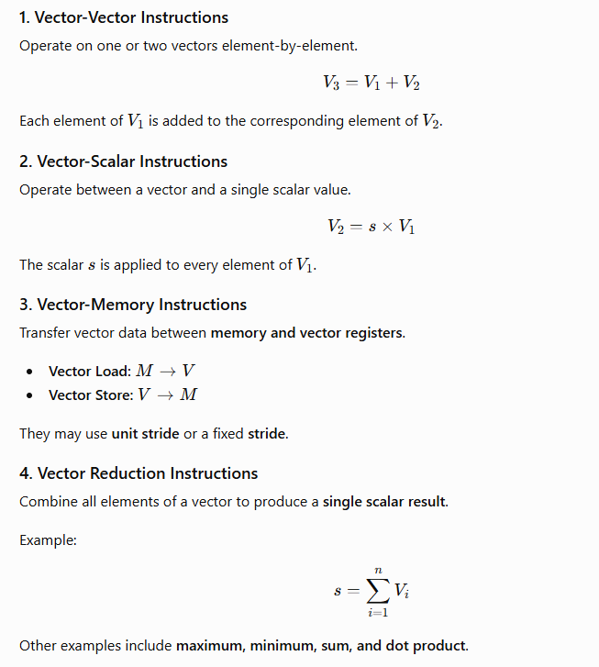
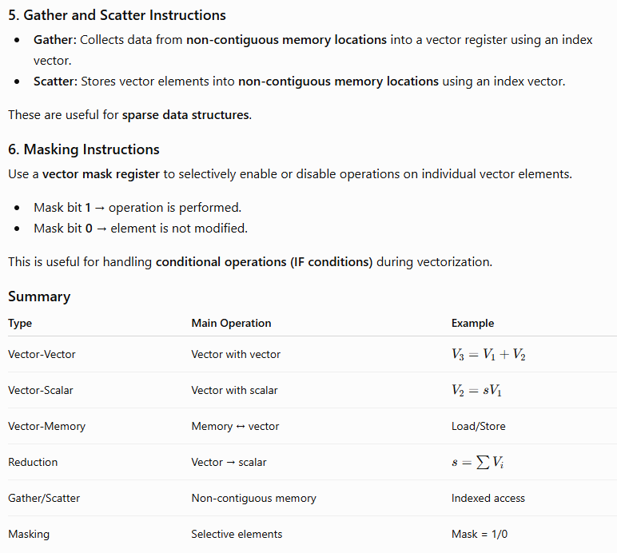In short: Vector processing performs multiple data operations in parallel, while the six major vector instruction types provide efficient support for arithmetic, memory access, reduction, sparse data, and conditional operations.

- Scalar vs. vector pipeline (Differentiate, 2025 Fall)
- What is vectorization? Discuss the challenges of vectorizing code and how a vectorizing compiler addresses these challenges.

Vectorization
Vectorization is the process of converting scalar sequential operations into parallel vector operations, where a single instruction operates on multiple data elements simultaneously. It is a form of SIMD (Single Instruction, Multiple Data) parallelism. Vectorization improves instruction throughput, reduces loop overhead, and is useful in scientific computing, image processing, AI, and data-intensive applications.

Challenges of Vectorizing Code
- Control Dependence: IF-ELSE statements inside loops create different execution paths and make parallel execution difficult.
- Loop-Carried Dependence: When one iteration depends on the result of a previous iteration, iterations cannot execute simultaneously.
- Non-Unit Stride: Non-contiguous memory access reduces memory efficiency and can increase cache and TLB misses.
- Sparse and Indirect Access: Accesses such as A[K[i]] generate irregular memory addresses, making vectorization difficult.
- Varying Vector Length: The loop size may not match the processor's Maximum Vector Length (MVL).
- Complex Loop Structure: Function calls, multiple loop exits, and I/O operations can prevent effective vectorization.

How a Vectorizing Compiler Addresses Them
Challenge | Compiler Technique
Control dependence | If-conversion and vector masking
Loop-carried dependence | Dependency analysis, node splitting, temporary variables
Scalar accumulation | Scalar expansion and vector reduction
Non-unit stride | Loop interchange and strided vector instructions
Sparse/indirect access | Gather and scatter instructions
Different loop length | Strip-mining and Vector-Length Register (VLR)
Uncertain dependencies | Programmer directives/hints

Conclusion
Vectorization converts sequential scalar code into SIMD-based parallel code to increase processor throughput. The main difficulties are data dependencies, control dependencies, irregular memory access, and varying vector lengths. A vectorizing compiler uses dependency analysis, masking, loop interchange, scalar expansion, gather/scatter, and strip-mining to overcome these limitations and generate efficient vector code.

- OR What are some of the use cases of vector database in advanced computing? Explain. (2024 Fall)
- What is vector processing? Explain the basic architecture of a vector processor with a suitable diagram. (2025 Fall Mock & 2025 Fall New)
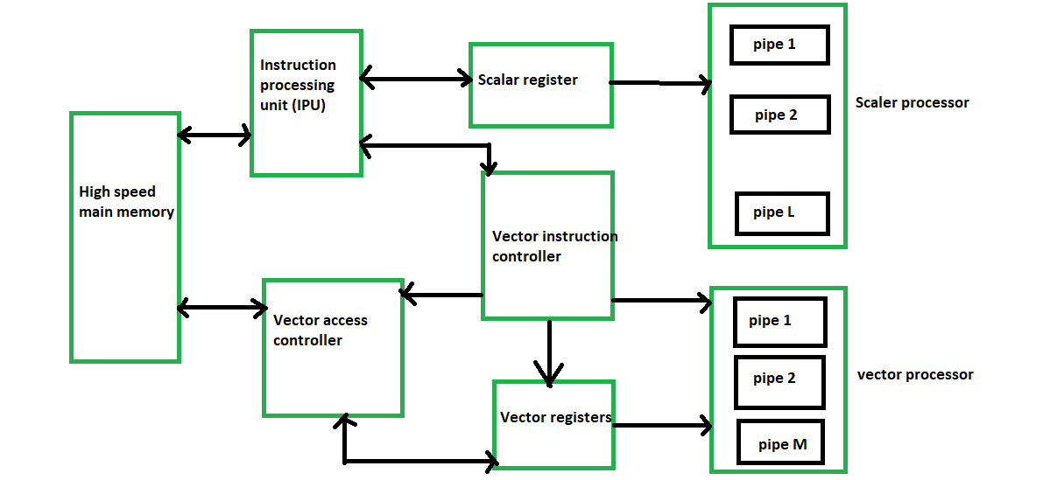
- What are some common use cases of vector databases in the field of data science and AI? Explain. (CA / Old)
3.12 Array Processors & SIMD Algorithms
- What is array processing? Explain different types of array processors. (2025 Fall)

Array Processing
Array processing is a technique in which an array processor performs the same operation on multiple data elements simultaneously. It exploits data-level parallelism and is commonly classified under SIMD (Single Instruction, Multiple Data) architecture.
Unlike scalar processing, which handles one data item at a time, array processing uses multiple processing elements (PEs) to perform operations on many array elements concurrently.

Types of Array Processors

1. Attached Array Processor
An attached array processor is a specialized accelerator connected to a general-purpose host computer.
- The host computer performs normal processing and control operations.
- Computationally intensive array and matrix operations are offloaded to the attached processor.
- It uses multiple functional units working in parallel.
- A high-speed memory-to-memory bus is generally used for communication.
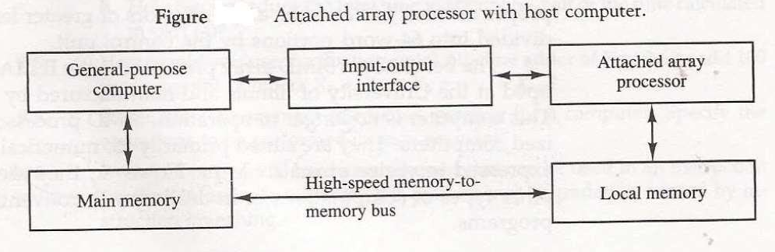
Example: A host computer sends a large matrix multiplication task to the attached array processor for faster computation.

2. SIMD Array Processor
A SIMD array processor contains multiple identical Processing Elements (PEs) controlled by a single Control Unit (CU).
- The CU fetches and broadcasts a single instruction to all PEs.
- All PEs operate synchronously in lockstep.
- Each PE has components such as an ALU, registers, and local memory.
- A masking mechanism can enable or disable selected PEs.
- An interconnection network allows PEs to exchange data.
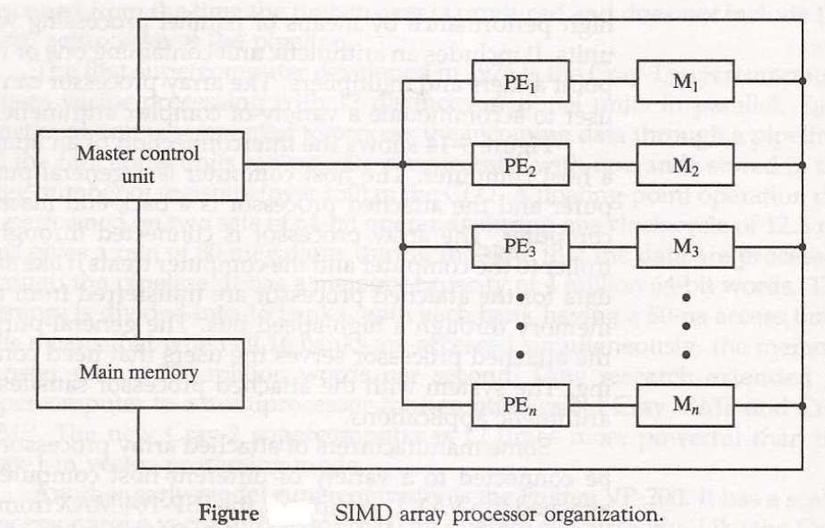
Example: For
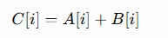
each PE can simultaneously add the corresponding elements of (A) and (B).

Comparison
Feature | Attached Array Processor | SIMD Array Processor
Relationship | Attached to host computer | Independent parallel architecture
Control | Host computer controls it | Single CU controls multiple PEs
Processing | Offloads intensive computation | Parallel processing of multiple data
Main technique | Parallel functional units | Multiple PEs in lockstep
Local memory | Generally shared/host-connected | Each PE may have local memory

Conclusion
Array processing improves performance by exploiting data parallelism. The two major types are Attached Array Processors, which act as accelerators for a host computer, and SIMD Array Processors, which use multiple synchronized processing elements under a single control unit.

- Array processor (Short Note, 2024 Fall)
- SIMD Array Processors (Short Note, 2025 Fall Mock)
- How can Cannon's algorithm and systolic arrays improve matrix multiplication efficiency in high-performance computing? Explain. (CA / Old)

